Lab 6 manual: Circuits, Breadboards and Kirchhoff’s rules
Dr. D. Beznosko
4/2/2025
For PHYS 2212L
(Lab outcomes: construct circuit from schematic, breadboard skills, application of Kirchhoff's rules.)

Abstract
A breadboard is a device that is used for rapid circuit prototyping and has very wide applications. An ability to construct the circuit or read the circuit diagram is commonly applicable to work with most electronic devices. Kirchhoff's rules are used for the analysis to obtain the operational parameters of the circuits.

Introduction
Kirchhoff's rules for the analysis of multiloop circuits: the sum of the currents entering any circuit junction is equal to the sum of the currents leaving the junction; the algebraic sum of the changes in potential across all elements around any closed-circuit loop is equal to zero. These are sufficient to analyze the operational parameters for the elements and parts of most circuits. Can you find any examples and practical uses for these rules?

Experimental Setup
The setup in Figure 1 shows a breadboard with resistors and connecting wires.
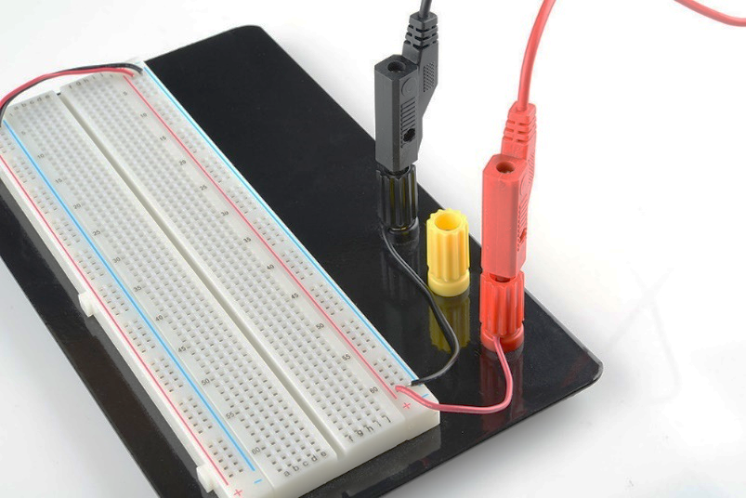
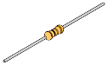
R3
Connecting wires
Breadboard
Resistors

Figure 1: The experimental setup schematic. A breadboard is used to construct circuit using wires and resistors. Power supplies and multimeters are not shown.

Procedure
The goal of the experiment is to find all currents and all voltages. Additionally, the resistance is found. (Note: resistors are denoted as boxed in all schematics for simplicity.) The basics of the breadboard will be explained in the lab by the instructor. Listen carefully and ask questions so that you don’t short any wires. Please exercise caution and be attentive to details!
Construct the circuit from Figure 2 from the resistors provided. Measure all given resistors, pick three such as each <1$kΩ$, choose $R_{5}$ to be the largest of the three, the other two are best with resistance values close to each other. $E_{2}$ should be the PASCO [1] computer interface and set to under 5V. Connect ammeter between $E_{1}$ and $R_{5}$. Set $E_{1}$ to about third of that value – observe how currents change and choose the best value. Record the $V_{1},V_{2},I_{1},I_{2}$ using PASCO interface. Remember to get the statistical and systematic errors, you should know how! (its different for multimeter and interface!)

$$R_{1}$$
$$R_{3}$$
$$R_{2}$$
$$E_{1}$$
$$E_{2}$$
$$R_{5}$$
$$R_{4}$$
$$R_{6}$$

Figure 2: Circuit schematic 2.

Experimental Data
The results of the measurements should be organized as Table 1 or similar and additional tables. Think about how to organize this table. The error can be listed in a different column or as value ± error unit. Don’t include all data values here, only relevant means, stdev etc. In most cases, individual data points are not needed, especially for computer-based labs.
Table 1: Experimental data.
Quantity name | Measured value, units
Resistor name | Resistance, $Ω$ | Something else?
$$R_{1}$$

Provide description about each entry as needed, don’t just leave the table without text in this section. Organize well so that data takes less space, but everything needed is included.

Theory
The relationships for equivalent resistance for series and parallel combinations of resistors in a circuit with emf applied are given by the following equations:
- For a series combination of resistors, the current in each resistor is the same:
$$I=I_{1}=I_{2}=I_{3}=⋯\left(1\right)$$
- The sum of the potential drops across all resistors are equal to the emf of the voltage source (including any internal resistances, etc…):
$$E=V1+V2+V3+…\left(2\right)$$
- For parallel combination of resistors, the potential difference across each resistor is the same:
$$V=V_{1}=V_{2}=V_{3}=…\left(3\right)$$

Kirchhoff's rules for the analysis of multiloop circuits are as follows:
- The sum of the currents entering any circuit junction is equal to the sum of the currents leaving the junction.
- The algebraic sum of the changes in potential across all elements around any closed-circuit loop is equal to zero.
Application of the second rule implies the following conventions:
- If an emf is traversed in the direction from minus (-) to plus (+) the change in potential is positive.
- If an emf is traversed in the direction from plus (+) to minus (-) the change in potential is negative.
- If a resistor is traversed in the direction of the current, the change in potential is negative. That is, $ΔV=V_{i}=−IR_{i}$
- If a resistor is traversed in a direction opposite that of the current, the change in potential is positive. $ΔV=V_{i}=+IR_{i}$
Using Kirchhoff's rules, a set of simultaneous linear equations is produced. This set of equations is then solved for the assumed currents.

Analysis
Hint: You can use the Wolfram Alpha [2] or similar computer software/online service to solve the system of equations. Propagate errors and compare with the values within respective errors. Simplified error propagation equations can be used!
Write the linear equations using Kirchhoff’s rules for the circuit. How many loops do you need for it? You have the resistances and voltages so find the currents in each loop. What is the error on the calculated $I_{1}$ and $I_{2}$ that you find? Recall that $I_{2}$ is the current associated with the $E_{2}$. Compare calculated currents with measured values within the errors.
Now, pretend that we don’t know $R_{4}$ but know $I_{2}$. Re-write the equations from above to find this resistance. Compare the theoretical and measured values. Which one has larger error and why?

Conclusion
Comment on your result and the methods used to find it. What did you learn in performing this measurement? Where else can it be used? Can this experiment be improved?

References

[1] | PASCO Scientific, 10101 Foothills Boulevard, Roseville, California 95747 USA.
[2] | "Wolfram Alpha," Wolrfam Inc., [Online]. Available: https://www.wolframalpha.com/.

